Nominzul and his father training a racehorse
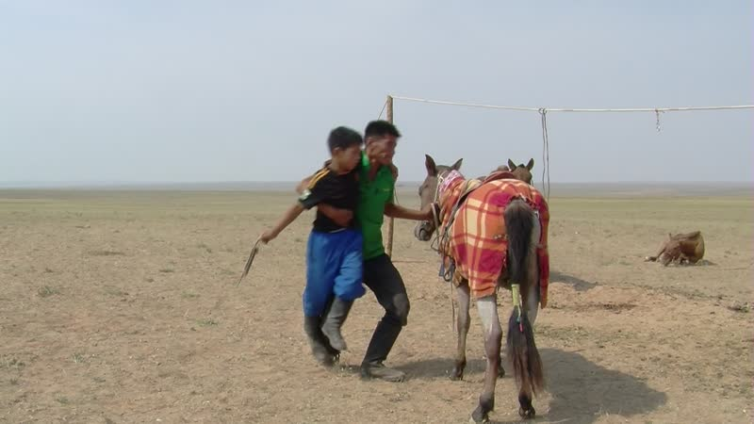

identifier
92ff4816-fd8f-4df6-bf9a-a33ea546eb16

creator
Thrift, Eric

type
Moving Image

coverage
Mongolia
Dornogovi aimag
Sainshand sum

description
This series of ethnographic field recordings shows Nominzul and his father (from near Choir) training a horse in preparation for the upcoming race at Khamar Monastery. Togtokh lama's grandson is the jockey. While the men are outside working with the horse, Oyunaa makes khuruud indoors.

publisher

source

rights

subject
Pastoralism Videos
Horse Training
Making Aaruul
Nomin-Oyunaa

date
2012-09-09

language

format
inode/directory

modified
2018-03-02 09:37:44

original filename
PastoralismVideos--2012-09-09--HorseTraining--MakingAaruul--Nomin-Oyunaa--Dornogovi-Sainshand.vclips

table of contents
time | clip | description
0:00:00 | 300G0128 01
0:13:53 | 300G0128 02
0:13:56 | 300G0129 01
0:14:37 | 300G0130 01
0:14:51 | 300G0131 01
0:16:03 | 300G0132 01
0:29:57 | 300G0132 02
0:43:51 | 300G0132 03
0:57:44 | 300G0132 04
1:01:28 | 300G0133 01
1:15:22 | 300G0133 02
1:17:55 | 300G0133 03
1:23:56 | 300G0134 01
1:35:03 | 300G0135 01

