Map of Inner Asia
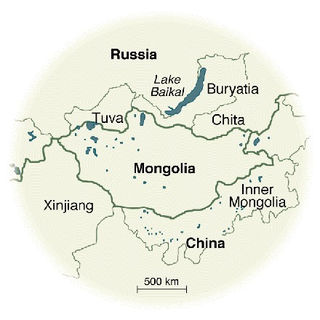

identifier
9301ad64-9ef7-439a-9efe-b90621c3001a

creator
Sneath, David

type
Image

coverage
Inner Asia

description
“Much of northern China, Mongolia, and southern Siberia is rolling grassland, used since ancient times for raising livestock. Inner Asia contains over 6% of the world's grassland—more than two and a half million square kilometers, an area more than seven times the size of Germany. Historically, most of this region was inhabited by Mongolian mobile pastoralists (nomads), who lived in felt tents and moved with their herds to different seasonal pastures. In contrast to Mongolia, the Chinese and Russian parts of Inner Asia have in this century seen dramatic changes in their patterns of land use as a result of very different state policies. These regions have very similar grassland environments, and thus a comparison of the landscapes of these different regions can reveal the effects of three alternative approaches to managing the Inner Asian environment—Russian, Chinese, and Mongolian.”

publisher
Science

source
DOI: 10.1126/science.281.5380.1147
Sneath, David. “State Policy and Pasture Degradation in Inner Asia”. *Science* 21 Aug 1998: Vol. 281, Issue 5380, pp. 1147-1148.

rights
© 1998 American Association for the Advancement of Science

subject
GIS
Inner Asia
rangeland ecology

date
1998

language
English

format
image/gif

modified
2017-10-07 15:43:04

extent
29.8 KiB
440x440 px

