Report on the use of remotely sensed data in the analysis of contemporary pastoralism in Inner Asia
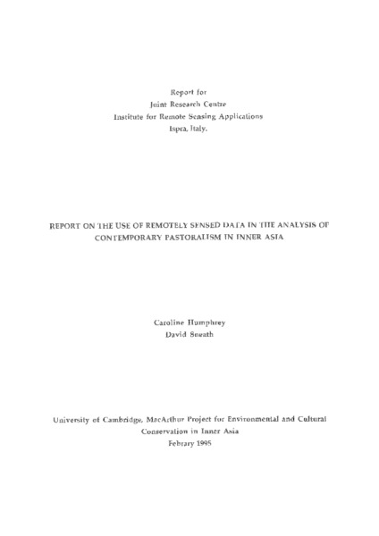

identifier
9598b8f2-6a82-4120-a196-5f7874260e55

creator
Sneath, David
Humphrey, Caroline

type
Text

coverage
Inner Asia

description

publisher

source
Scanned from an original document held in the archives of the Mongolia and Inner Asia Studies Unit, University of Cambridge.

rights

subject
GVI
remote sensing

date
1995

language
English

original filename
remote-sensing-and-pastoralism-report.pdf

relation

extent
6.0 MiB

contributor

format
application/pdf

modified
2017-05-29 12:12:49

