Caroline Humphrey - Buryatia photos - No. 4-17
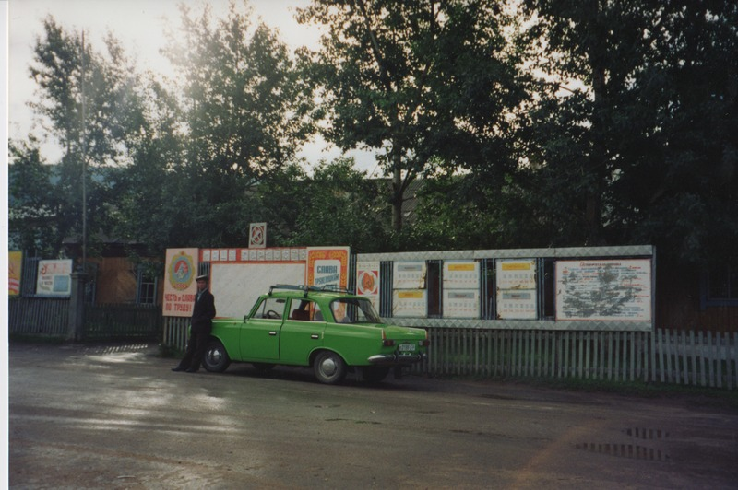

identifier
96c4f557-588d-4b8e-83fb-da4d3b5980b0

creator
Humphrey, Caroline

type
Image

coverage
Uro
Bayangol
Buryatia
USSR

description

publisher

source
Scanned from a print held in the archives of the Mongolia and Inner Asia Studies Unit, University of Cambridge.

rights

subject

date
1993

language

extent
3.5MiB
1799x1196 px

contributor

original filename
Humphrey-Buryatia-photos-4-17.png

relation

format
image/png

