Kinship terminology of the Barguzin Buryats, 1967
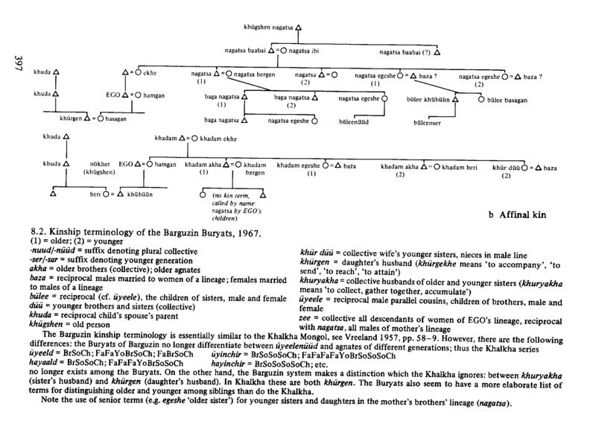

identifier
97305e13-4f19-4f34-9af5-ebabf201397c

creator
Humphrey, Caroline

type
Image

coverage
USSR
Buryatia

description
Affinal kin

publisher

source
Karl Marx Collective

rights

subject

date

language
Buryat
English

contributor

original filename
kinship-diagram.png

relation

extent
85.5KiB
1930x2805 px

format
image/png

