Caroline Humphrey - Buryatia photos - No. 2-15
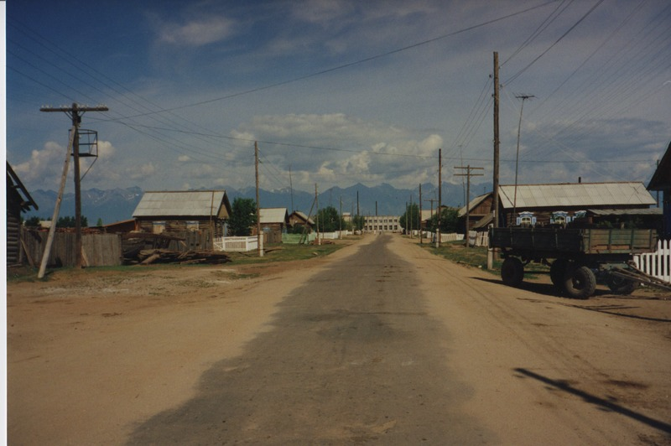

identifier
98ce74c5-3910-444b-8809-8a2b6bb18160

creator
Humphrey, Caroline

type
Image

coverage
Bayangol
Khilgana
Karl Marx Collective
Buryatia
USSR

description
View of the town centre.

publisher

source
Scanned from a print held in the archives of the Mongolia and Inner Asia Studies Unit, University of Cambridge.

rights

subject

date
1993

language

contributor

original filename
Humphrey-Buryatia-photos-2-15.png

relation

extent
3.3MiB
1799x1196 px

format
image/png

