Gerlee cooking and milking her cow
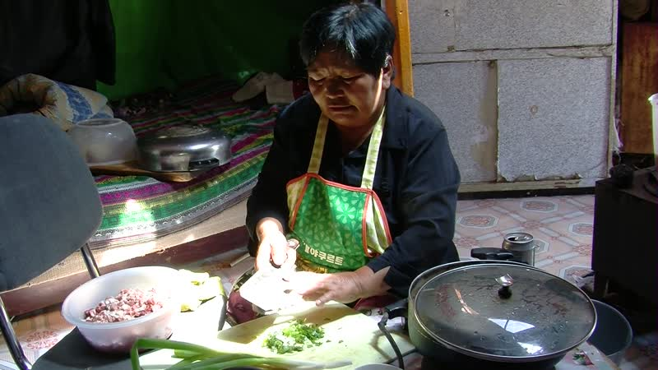

identifier
9dd82051-c8f8-4d19-a8e6-3895fe8dc8d2

creator
Thrift, Eric

type
Moving Image

coverage
Mongolia
Selenge aimag
Yeröö sum

description
This series of audiovisual recordings documents Gerlee's work in the home. She spends the afternoon making khailmag (a confection made with clotted cream, flour, raisins, and sugar), khuushuur (meat pies), and boortsog (biscuits), with some help from her son Nyamdorj and from her visitors. The food preparation is done indoors, but Gerlee does much of her cooking on a stove outside, so as to keep the yurt from getting too hot. As it begins to get dark her cow comes home. Gerlee goes over to the neighbour's pen where her cow and calf spend the night, and milks the cow, then returns home with a pail of fresh milk.

publisher

source

rights

subject
Pastoralism Videos
Making Boortsog
Making Khailmag
Making Khuushuur
Milking Cattle
Gerlee-Nyamdorj

date
2012-07-20

language

format
inode/directory

modified
2018-03-02 09:37:44

original filename
PastoralismVideos--2012-07-20--MakingBoortsog--MakingKhailmag--MakingKhuushuur--MilkingCattle--Gerlee-Nyamdorj--Selenge-Yeroo.vclips

table of contents
time | clip | description
0:00:00 | 300G0054 01 | Gerlee places frozen dairy fat (shar tos) into the cooker, adds water, and sets it to melt. Once the fat has melted she pours it into a pot and adds salt, yeast, and a scoop of flour. She goes out to wash her hands, then returns inside. She adds more flour to the water and fat mixture.
0:13:53 | 300G0054 02 | Gerlee adds flour to the water and begins to knead the dough. After kneading for a while she sets it on a board and covers it with an overturned pot, then leaves it to rise. Children play outside on a bed next to the yurt. Nyamdorj and Narangarav begin cutting cabbage. Gerlee scoops clotted cream into the pot, to make khailmag.
0:27:47 | 300G0054 03 | Gerlee waits for the clotted cream to heat up, then spoons off the oil that rises to the surface. She adds sugar to the cream. then adds some water and stirs the mixture. Nyamdorj peels carrots. Gerlee adds raisins, and continues to heat and stir.
0:41:41 | 300G0054 04 | Gerlee finishes making the khailmag, and removes it from the pot onto a plate.
0:55:34 | 300G0054 05
1:09:28 | 300G0054 06
1:23:22 | 300G0054 07
1:37:16 | 300G0054 08
1:51:10 | 300G0054 09
2:00:08 | 300G0054 10
2:04:38 | 300G0055 01
2:18:32 | 300G0055 02
2:32:25 | 300G0055 03
2:39:09 | 300G0056 01
2:53:02 | 300G0056 02
3:06:56 | 300G0056 03
3:20:50 | 300G0056 04
3:26:55 | 300G0057 01
3:40:49 | 300G0057 02

