Mongolia, Interview with Mongolian Teenager Erika: Part 1 of 2
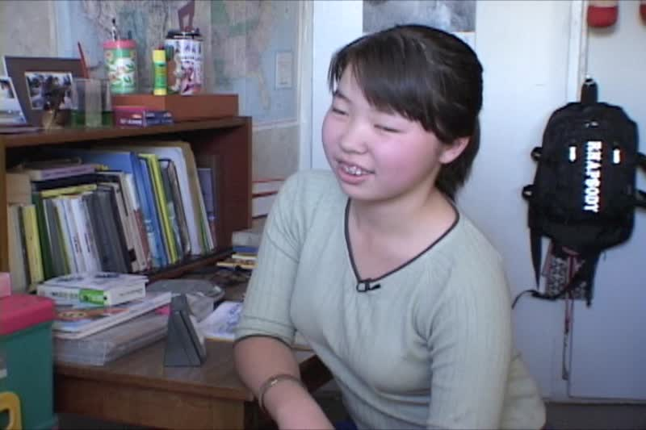

identifier
9f7b3b09-7533-47df-b8ff-37818a3723d5

creator
Penn Museum

type
Moving Image

coverage
Mongolia
Ulaanbaatar

description
Interview with teenager Erika, daughter of Bat-erdene and Tsetseglen (filmed in Ulaanbaatar/in English)

publisher
University of Pennsylvania Museum of Archaeology and Anthropology Films

source
<https://archive.org/details/UPMAA_films>

rights
All rights are reserved by the University of Pennsylvania Museum of Archaeology and Anthropology (Penn Museum). Any use of the footage in productions is forbidden unless rights have been secured by contacting the Penn Museum Archives at 215-898-8304, or email photos@pennmuseum.org. This film and all of the films in the Penn Museum collection are copyrighted by the Penn Museum, and are not in the public domain.

subject

date
2011-06-23 12:07:50

language
English

original filename
Mongolianteeninterview.mov

extent
1.8 GiB
3363.363333

format
video/quicktime

modified
2017-05-25 11:06:40

remote embed url
https://archive.org/embed/V-450-14

public
FALSE

