David Sneath - photographs from Xingmeng, Yunnan - No. 06
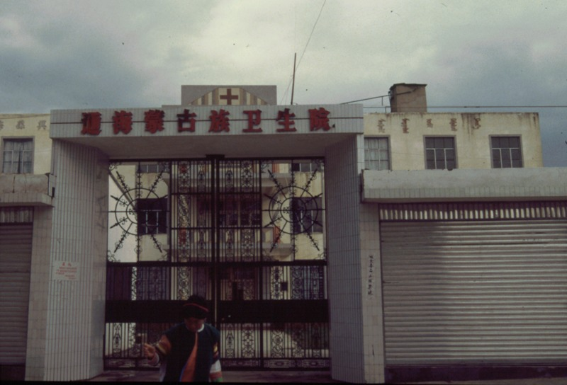

identifier
a1629abe-15cd-4cb7-ad96-e490cd0a604f

creator
Sneath, David

type
Image

coverage
PRC
Yunnan

description
The health centre with its Chinese sign, and with its Mongolian sign visible on the left.

publisher

source
Digitized from a 35mm slide provided by the author.

rights

subject

date
1997

language

format
image/tiff

contributor

original filename
David Sneath - photographs from Xingmeng, Yunnan - No. 06.tif

relation

extent
42.6MiB
4704x3168 px

public

