Website of the Mongolia and Inner Asia Studies Unit
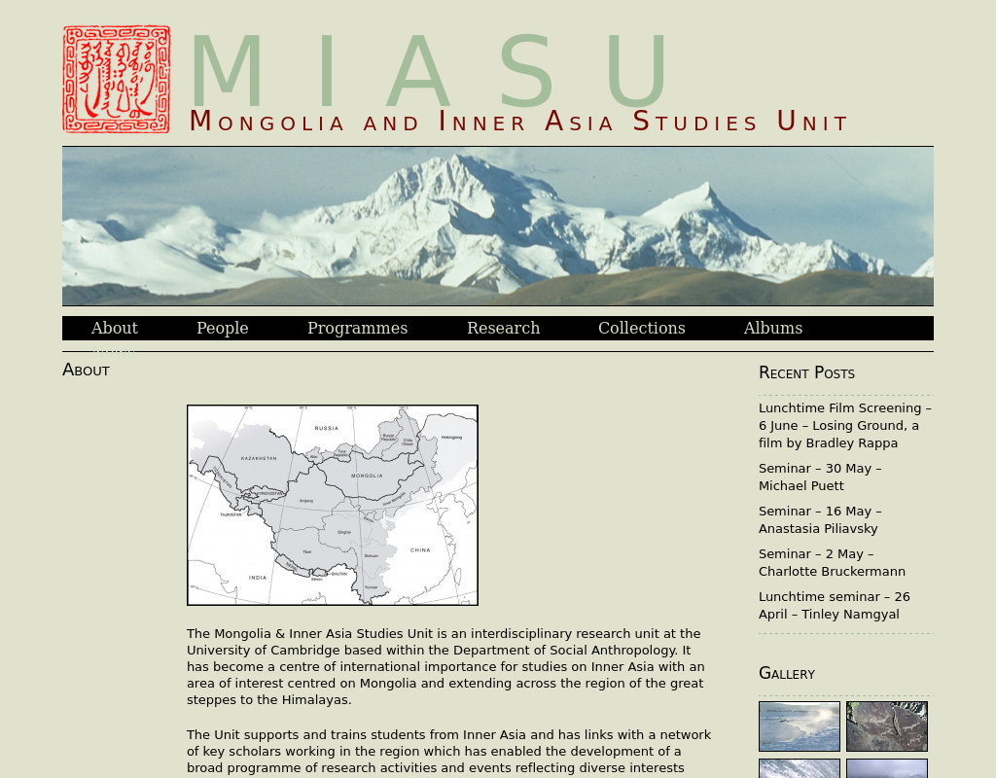

identifier
a2b1401d-ff03-4d7c-b6f2-9a01bd0ef739

creator
MIASU

type
Text

coverage

description

publisher

source

rights

subject
MIASU

date
2017-05-25 10:48:08

language
English

original filename
miasu-website.url

extent
29.0 B

format
text/plain

modified
2017-05-25 08:43:32

