Oral history interview No. 090759A with Ariunzaya (b. 1976): transcript
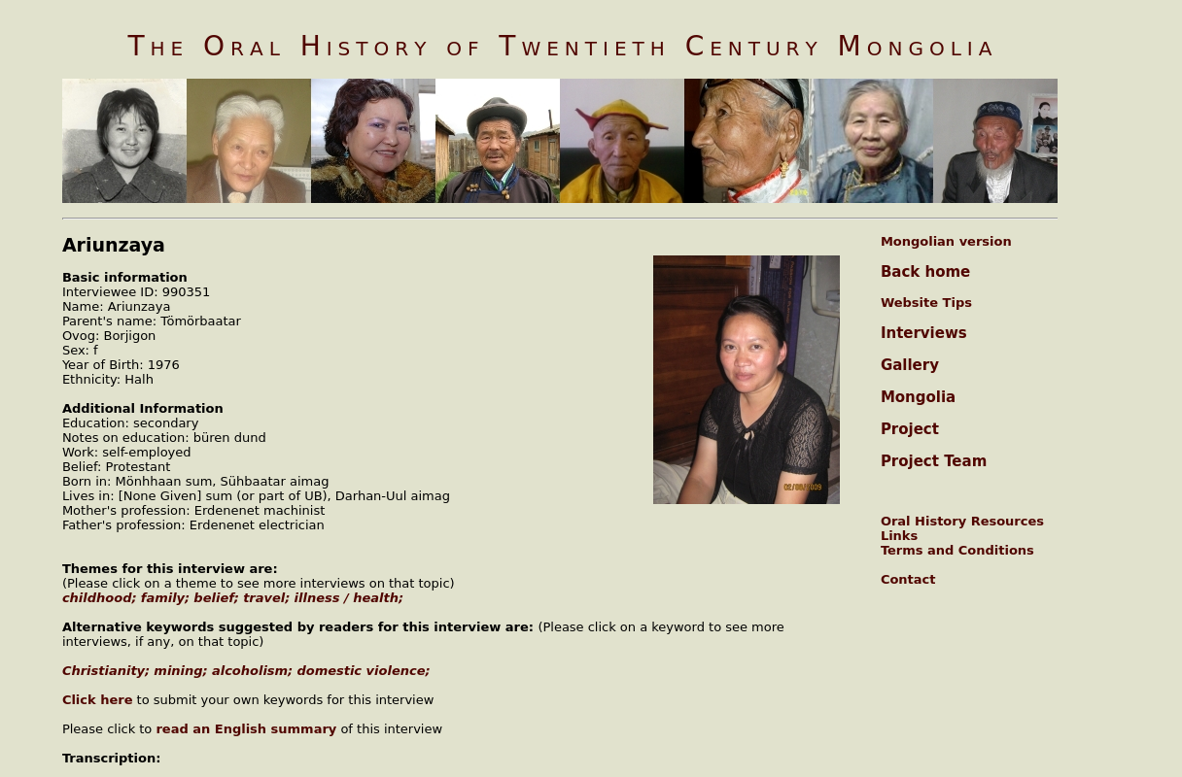

identifier
a7069e3a-ae67-4c4b-a6e1-e4a9f1f5752f

creator
Ariunzaya

type
Text

coverage

description

publisher
Oral History of Twentieth Century Mongolia

source
<http://amantuuh.socanth.cam.ac.uk/search/view_transcript.php?Interview=090759A>

rights
Copyright MIASU. Reproduced with permission. Brief excerpts from interviews and other material may be used in academic or popular work for non-commercial purposes provided proper attribution and credit is given to the Oral History of Twentieth Century Mongolia and the Mongolia and Inner Asia Studies Unit (MIASU). You must not: (a) republish this material (including republication on another website) without the express written permission of MIASU; (b) sell, rent or sub-license material from the website; (c) show any material from the website in public without attribution to The Oral History of Twentieth Century Mongolia; (d) reproduce, duplicate, copy or otherwise exploit material on the website for a commercial purpose without express written permission; (e) use the material in any way that is damaging to the project or any of the persons named in the interviews. See <http://amantuuh.socanth.cam.ac.uk/terms.php> for details.

subject

date
2009

language
Mongolian

format
text/plain

contributor
Otgonbayar

original filename
090759A-Ariunzaya-transcript.url

relation
711feb02-ea1b-4fa4-aa2c-5ae3b7311007

extent
79.0 B

