Caroline Humphrey - Buryatia photos - No. 13
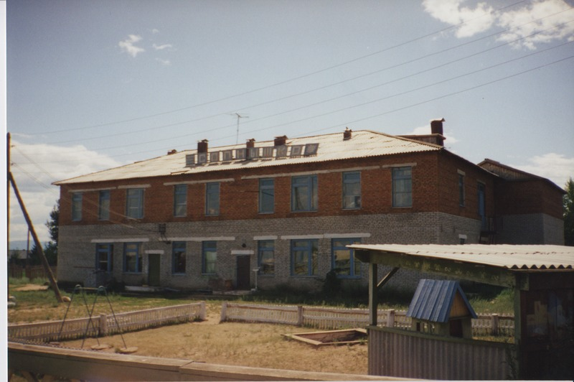

identifier
a7bf0062-8eca-4fe8-b91d-05b1becc2e54

creator
Humphrey, Caroline

type
Image

coverage
Ulung Collective
Buryatia
USSR

description
Creche.

publisher

source
Scanned from a print held in the archives of the Mongolia and Inner Asia Studies Unit, University of Cambridge.

rights

subject

date
1993-07-25

language

contributor

original filename
Humphrey-Buryatia-photos-13.png

relation

extent
3.2MiB
1799x1196 px

format
image/png

