Approximate extent of the Eurasian Steppe grasslands ecoregion, and Eurasia cultural region
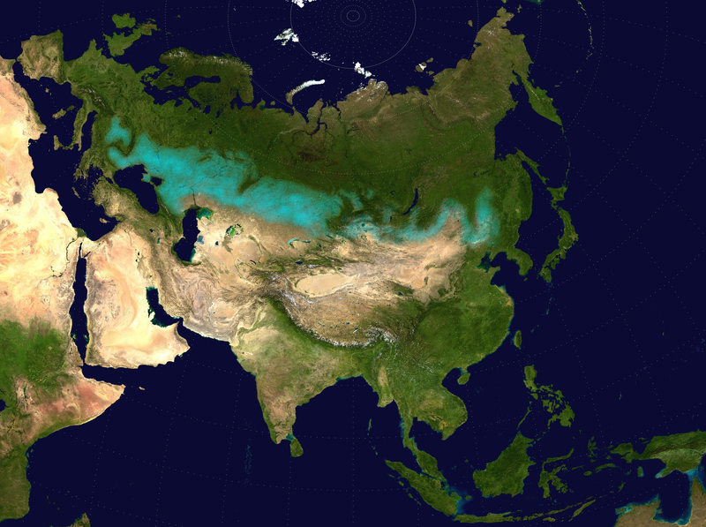

identifier
a8f8f6c9-ddc9-4d04-b8c2-2606a80a26c6

creator
Wikimedia Commons User:Clivius
Wikimedia Commons User:Cp6
Wikimedia Commons User:Shattered Gnome

type
Image

coverage
Eurasian steppe

description
Approximate extent of the Eurasian Steppe grasslands ecoregion, and Eurasia cultural region. In northern Eastern and Central Asia, and westward into Eastern Europe, in areas of Russia, Ukraine, Moldavia, and Hungary. Based on file Two-point-equidistant-asia. A Two Point Equidistant projection of Asia. The control points are at 35N 40E and 35N 140E. The source image is a product of NASA's Blue Marble project.

publisher
Wikimedia Commons

source
<https://commons.wikimedia.org/wiki/File:Eurasian_steppe_belt.jpg>

rights
Public domain

subject
maps
rangeland

date
2009

language
N/A

original filename
Eurasian_steppe_belt.jpg

extent
1.6 MiB
2048x1529 px

contributor
NASA

format
image/jpeg

modified
2017-10-08 13:05:28

