Photographs of Dashbalbar sum, No. 26
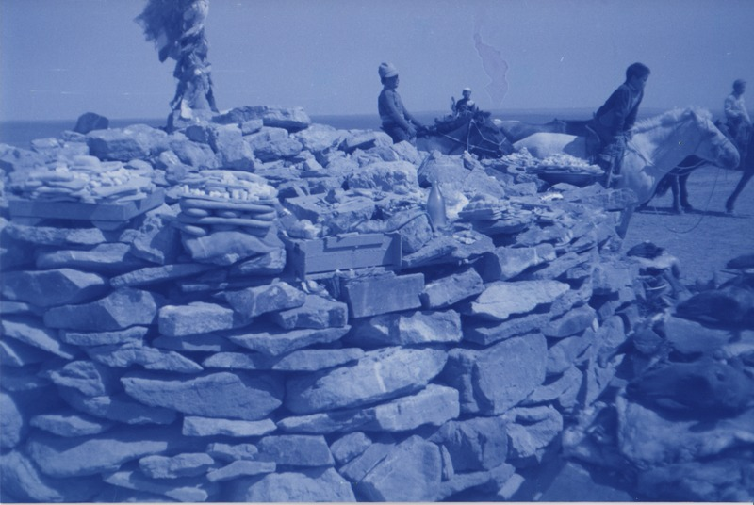

identifier
aa65af26-99c7-44eb-a2c5-917d12b3d8f5

creator
Batbuyan B.

type
Image

coverage
Dashbalbar sum
Dornod aimag
Mongolia

description
Ovoo worship in Dashbalbar.

publisher

source
Scanned from a photographic print held in the archives of the Mongolia and Inner Asia Studies Unit, University of Cambridge.

rights

subject
ovoo

date
1993

language

format
image/png

contributor

original filename
bair-batbuyan-photos-26.png

relation

extent
1777x1191 px
3.0 MiB

