Photograph from Govisumber, No. 26
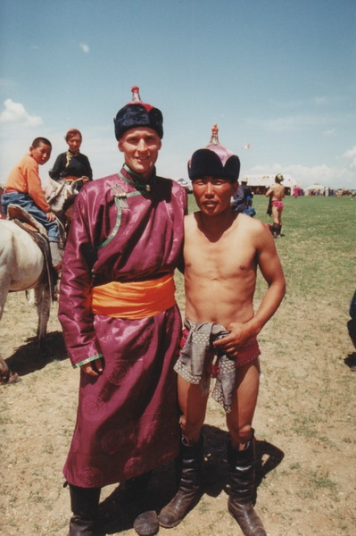

identifier
ac1e59af-a045-4668-9d6e-9fcd25e2bd7c

creator
Sneath, David

type
Image

coverage
Govisumber aimag
Mongolia

description

publisher

source
scanned from a photographic print held in the archives of the Mongolia and Inner Asia Studies Unit, University of Cambridge

rights

subject
anthropologists in the field
wrestling

date
1995

language

format
image/png

contributor

original filename
sneath-govisumber_26.png

relation

extent
1182x1776 px
3.2MiB

