Mongolia, Interview with Mongolian Teenager Erika, Part 2; Zanaa Jurmed
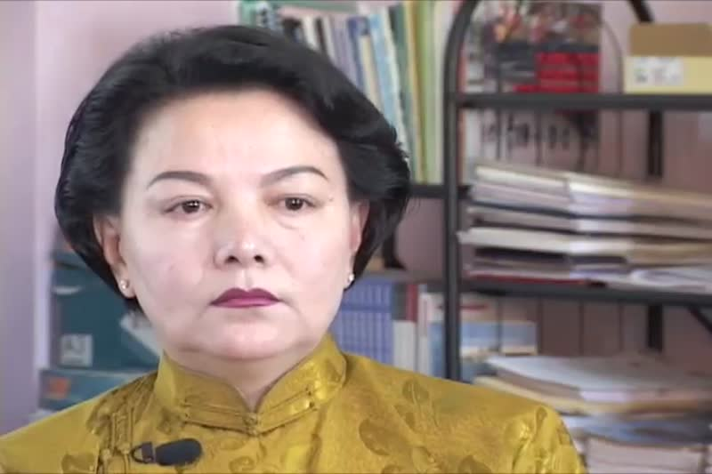

identifier
ad4db05c-d12a-491a-96da-75c08897ed2e

creator
Penn Museum

type
Moving Image

coverage
Mongolia
Ulaanbaatar

description
Erika Interview Part 2 of 2. B roll - Erika with younger sister Betty. Zanaa Jurmed Interview. Zanaa's personal photos include some from 1990 hunger strike.

publisher
University of Pennsylvania Museum of Archaeology and Anthropology Films

source
<https://archive.org/details/UPMAA_films>

rights
All rights are reserved by the University of Pennsylvania Museum of Archaeology and Anthropology (Penn Museum). Any use of the footage in productions is forbidden unless rights have been secured by contacting the Penn Museum Archives at 215-898-8304, or email photos@pennmuseum.org. This film and all of the films in the Penn Museum collection are copyrighted by the Penn Museum, and are not in the public domain.

subject

date
2011-07-07 14:38:59

language
Mongolian

original filename
V-450-15.mov

extent
131.2 MiB
3608.708333

format
video/quicktime

modified
2017-05-25 07:29:08

remote embed url
https://archive.org/embed/V-450-15-2

public
FALSE

