Haymaking at Khandgait, Yeröö sum, Selenge aimag
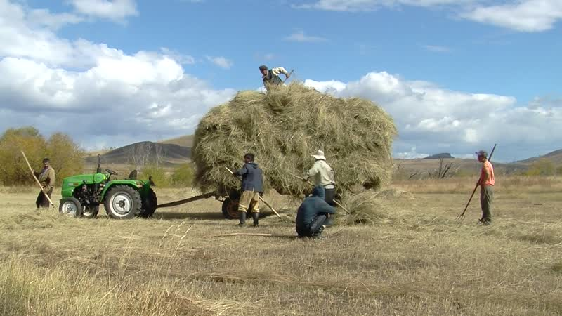

identifier
ae436c24-b5e4-4f77-aaee-3bdc8b9a27af

creator
Thrift, Eric

type
Moving Image

coverage
Mongolia
Selenge aimag
Yeröö sum

description
The recordings in this series depict the gathering and transportation of hay by herders in Yeröö. The hay was cut several days previously, and is now being loaded onto lightweight trucks (Porter/Bongo) and transported to the respective households' winter camps. The sides and tailgates of the trucks have been laid open and reinforced with narrow logs in order to accommodate larger loads. These recordings document the second of three loads of hay being transported on this day.

publisher

source

rights

subject
Pastoralism Videos
Hay Making

date
2012-09-25

language

remote embed url
https://archive.org/embed/ae436c24-b5e4-4f77-aaee-3bdc8b9a27af

modified
2018-01-18 09:56:18

table of contents
time | clip | description
0:00:00 | 300G0180 01 | Loading hay. Pulling a truck out of a stream bed, where it became stuck on crossing.
0:13:53 | 300G0180 02 | Loading hay. Another family's truck carrying hay drives by. The men tie down the load.
0:27:46 | 300G0180 03 | Loading hay onto the back of a trailer pulled by a tractor.
0:41:39 | 300G0180 04 | Loading hay onto the back of a trailer pulled by a tractor.
0:55:33 | 300G0180 05 | Loading hay onto the back of a trailer pulled by a tractor.
1:09:27 | 300G0180 06 | Loading hay onto the back of a truck.
1:11:36 | 300G0181 01 | The men finish loading hay onto the flat-bed trailer, and tie it down.
1:25:30 | 300G0181 02 | Tying down the load of hay.
1:29:06 | 300G0182 01 | Tying down the load of hay.
1:29:46 | 300G0183 01 | Following the haymakers as they drive the loads of hay towards a winter camp.
1:30:47 | 300G0185 01 | Following the haymakers as they drive the loads of hay towards a winter camp.
1:31:38 | 300G0186 01 | Following the haymakers as they drive the loads of hay towards a winter camp. Partway there, outside another family's winter camp, the drivers stop to adjust the load.
1:40:36 | 300G0187 01 | Arrival at the winter camp.
1:44:39 | 300G0188 01 | Unloading hay.
1:58:33 | 300G0188 02 | Unloading hay, pushing it with a log driven by the tractor.
1:58:43 | 300G0188 03 | Unloading hay.

