“Оргил хүнс” хятад тараг савлав уу | Чухлыг онцлов
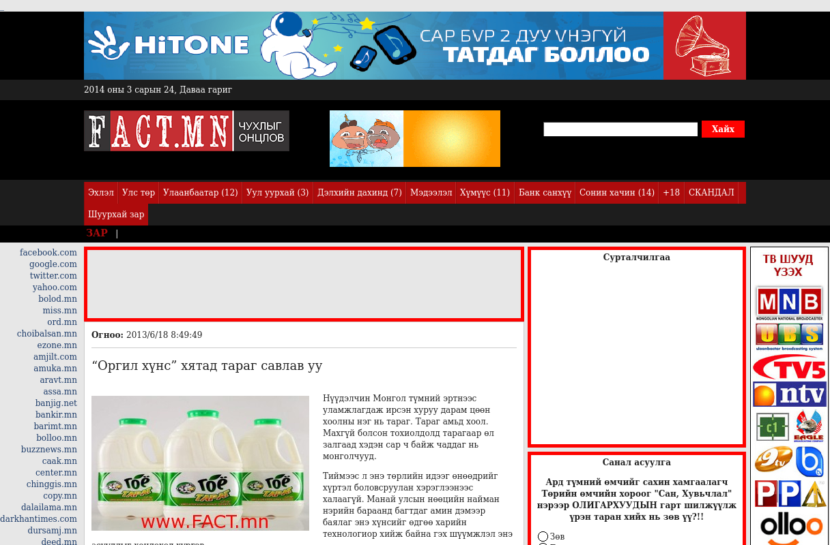

identifier
af2c167b-19b6-4de0-a9ea-bceb63c16e29

creator

type
Text

coverage
Mongolia

description

publisher

source
http://www.fact.mn/108780.html

rights

subject
Mongolia
dairy
nationalism
social media

date
24 Mar 2014 14:12:45

language
Mongolian

format
text/plain

modified
2018-01-11 14:12:43

original filename
fact.mn.Khyatad_tarag_savlav_uu.url

extent
30.0 B

