Caroline Humphrey - Buryatia photos - No. 3-10
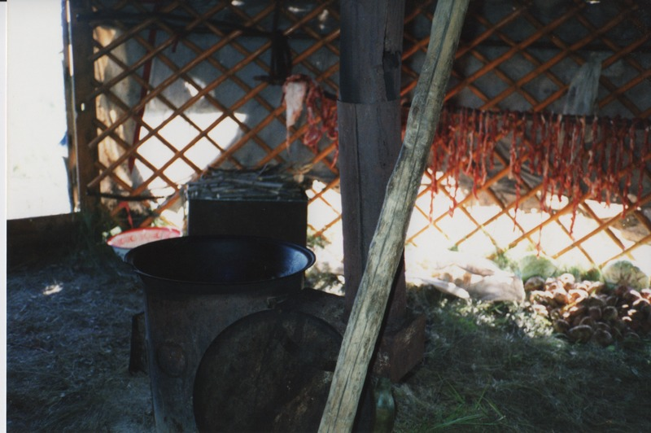

identifier
bf5ab872-0427-4458-972f-e9d66e1dd760

creator
Humphrey, Caroline

type
Image

coverage
Khargant

description
Strips of meat (*borz*) hanging to dry inside the yurt.

publisher

source
Scanned from a print held in the archives of the Mongolia and Inner Asia Studies Unit, University of Cambridge.

rights

subject

date
1993

language

contributor

original filename
Humphrey-Buryatia-photos-3-10.png

relation

extent
3.4MiB
1799x1196 px

format
image/png

