4022
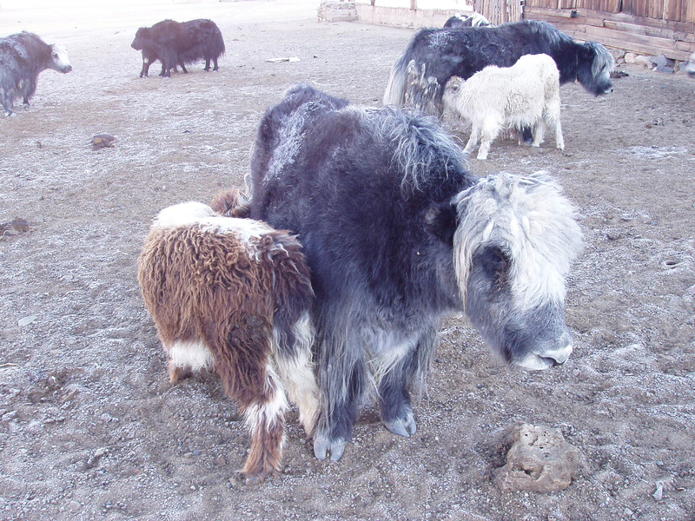

identifier
c0da0bc2-232c-4e41-bc76-be8ee11a3e44

creator
Boldbaatar, Yu.

type
Image

coverage
Mongolia

description
A female yak suckling a orpan

publisher

source
https://ich.unesco.org/img/photo/src/4022.jpg

rights

subject

date
2010

language

original filename
04022.jpg

extent
1.8 MiB
2048x1536 px

format
image/jpeg

modified
2012-12-05 02:28:25

