Introduction to Field Reports in Mongolian Ethnology (1960-1971)
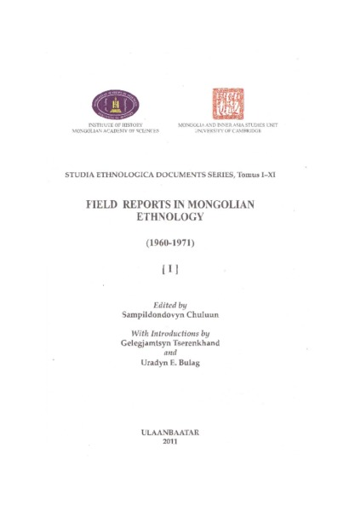

identifier
c0eca0a5-25fc-4a8c-b338-0d0a40c91dbb

creator
Bulag, Uradyn E

type
Text

coverage
Mongolia

description
Survey of the origins and development of Mongolian anthropology. This is one of two introductions to the first of an eleven-volume series compiling field reports by the first generation of Mongolian ethnographers, published by the Mongolian Academy of Sciences in collaboration with the Mongolia and Inner Asia Studies Unit at the University of Cambridge in 2011.

publisher
Institute of History, Mongolian Academy of Sciences

source

rights

subject
Mongolian ethnography
indigenous anthropology

date
2011

language
English

extent
4.6MiB

format
application/pdf

contributor

relation

original_filename
Foundations_of_Mongolian_ethnography.pdf

public

