Photograph from Govisumber, No. 16
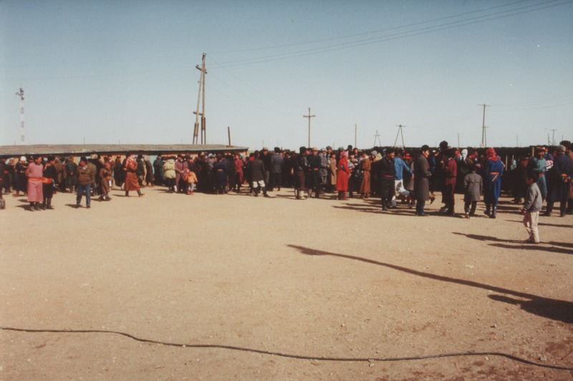

identifier
c12d6aff-9b1f-4ea8-884d-fc86480830e9

creator
Sneath, David

type
Image

coverage
Govisumber aimag
Mongolia

description

publisher

source
scanned from a photographic print held in the archives of the Mongolia and Inner Asia Studies Unit, University of Cambridge

rights

subject
settlements

date
1995

language

format
image/png

contributor

original filename
sneath-govisumber_16.png

relation

extent
1776x1182 px
3.1MiB

