Caroline Humphrey interview part 2
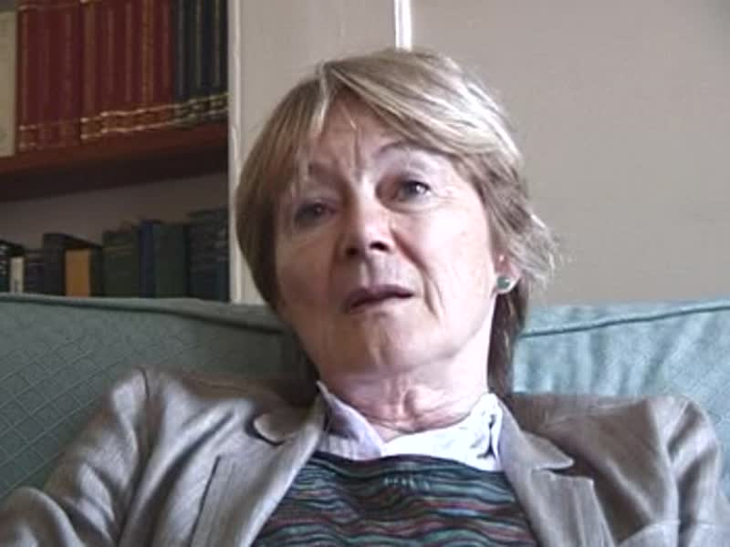

identifier
c1d62500-8261-4498-92a3-e45438786f88

creator
Humphrey, Caroline

type
Moving Image

coverage
Buryatia
Russia
USSR

description
Caroline Humphrey interviewed by Alan Macfarlane on 5th August 2010

publisher

source
MIASU

rights

subject

date
2017-05-25 10:42:32

language

extent
247.2MiB
2295.680000

contributor
Macfarlane, Alan

original filename
Caroline-Humphrey-interview-part-2.mp4

relation

format
video/mp4

