Can the subalterns not speak? On the regime of oral history in Socialist China
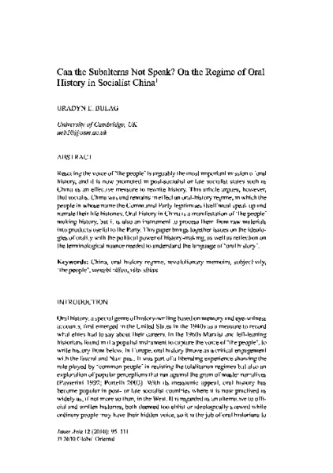

identifier
c2614acd-42b7-408e-9e17-e747d22527de

creator
Bulag, Uradyn E

type
Text

coverage
Inner Mongolia
PRC

description
Rescuing the voice of 'the people' is arguably the most important mission of oral history, and it is now promoted in post-socialist or late socialist states such as China as an effective measure to rewrite history. This article argues, however, that socialist China was and remains in effect an oral-history regime, in which the people in whose name the Communist Party legitimises itself must speak up and narrate their life histories. Oral history in China is a manifestation of 'the people' making history, but it is also an instrument to process them from raw materials into products useful to the Party. This paper brings together issues on the ideologies of orality with the political power of history-making, as well as reflection on the terminological nuance needed to understand the language of' oral history' .

publisher
Inner Asia

source
Inner Asia 12(2010): 95--111

rights

subject
indigenous anthropology
nationalism
oral history

date
2011

language
English

extent
1.2MiB

format
application/pdf

contributor

relation

original_filename
Can_the_Subalterns_not_speak.pdf

public
FALSE

