Field guide for Operation Raleigh researchers
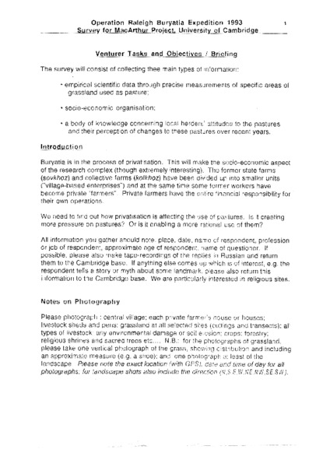

identifier
c36ebd5c-ea39-4f7b-8596-99f4ac35a186

creator

type
Text

coverage
Buryatia
Russian Federation

description
Document providing instructions to fieldworkers (“venturers”) collaborating with the University of Cambridge through the Operation Raleigh Buryatia Expedition, 1993. In conjunction with Raleigh International, non-professional anthropologists were trained in basic ethnographic research methods, and supervised in the collection of ethnographic survey data in Bayangol, Buryatia. As described in this field guide, the survey collected information on rangeland condition, through transect and spot measurements; socio-economic organization; and local herders’ opinions of rangeland conditions and their perceptions of changes in recent years.

publisher
Mongolia and Inner Asia Studies Unit, University of Cambridge

source
Scanned from an original document held in the archives of the Mongolia and Inner Asia Studies Unit, University of Cambridge.

rights

subject
research planning

date
1993

language
English

original filename
raleigh-fieldworker-instructions.pdf

relation

extent
4.6 MiB

contributor

format
application/pdf

modified
2017-05-29 12:12:49

