eagle.mn
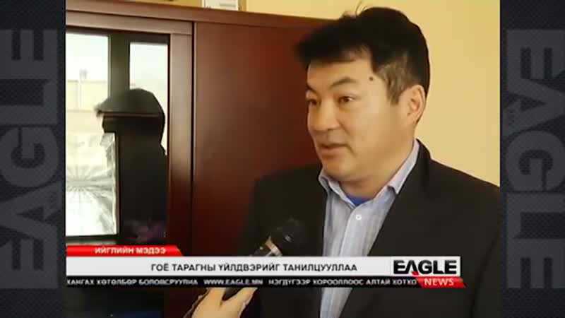

identifier
c3e4c49a-c3a5-4c09-838f-d8b2b3651922

creator
Eagle TV

type
Moving Image

coverage
Mongolia

description
News report from Eagle TV

publisher

source

rights

subject
Mongolia
dairy
nationalism
social media

date

language
Mongolian

