Excerpt from “Living with Herds”
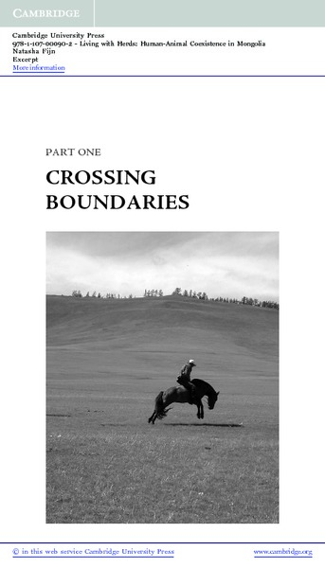

identifier
c44544f5-f99f-4a9c-a83e-a0e90bfbd555

creator
Fijn, Natasha

type
Text

coverage
Mongolia

description
This extract from the publisher presents the introductory pages from “Living with Herds: Human-animal coexistence in Mongolia”. Natasha Fijn describes her entry into the field.

publisher

source
<http://www.cambridge.org/catalogue/catalogue.asp?isbn=9781139005739&ss=exc>

rights
These resources are provided free of charge by Cambridge University Press with permission of the author of the corresponding work, but are subject to copyright. You are permitted to view, print and download these resources for your own personal use only, provided any copyright lines on the resources are not removed or altered in any way.

subject

date
2011

language
English

format
application/pdf

contributor

original filename
9781107000902_excerpt.pdf

remote embed url

relation
df6b0204-7aa1-48c0-8bc7-e9abe079d6ec

extent
352.2KiB

