4017
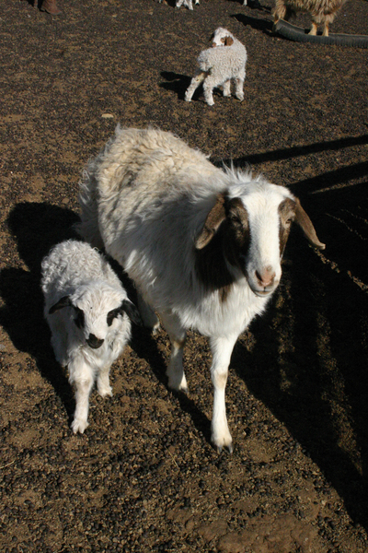

identifier
c488bd2c-159c-4203-8b7b-033b055484cc

creator
Boldbaatar, Yu.

type
Image

coverage
Mongolia

description
Adopt an orpan

publisher

source
https://ich.unesco.org/img/photo/src/4017.jpg

rights

subject

date
2010

language

original filename
04017.jpg

extent
4.6 MiB
2048x3072 px

format
image/jpeg

modified
2012-12-05 02:28:26

