Mongolia, Ulaanbaatar Nightlife
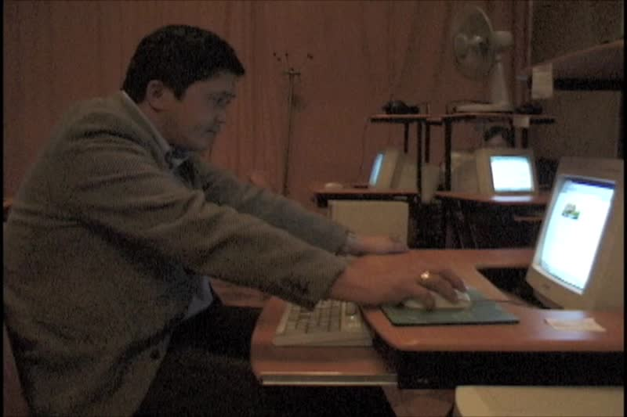

identifier
c48d4ff4-c316-439b-aaf0-5ba4d5b76df8

creator
Penn Museum

type
Moving Image

coverage
Mongolia
Ulaanbaatar

description
[0:00] Interior of apartment.
[9:00] Couple holding hands.
[10:00] Night club.
[18:42] City at twilight.
[19:51] Internet Café.
[31:00] Disco.

publisher
University of Pennsylvania Museum of Archaeology and Anthropology Films

source
<https://archive.org/details/UPMAA_films>

rights
All rights are reserved by the University of Pennsylvania Museum of Archaeology and Anthropology (Penn Museum). Any use of the footage in productions is forbidden unless rights have been secured by contacting the Penn Museum Archives at 215-898-8304, or email photos@pennmuseum.org. This film and all of the films in the Penn Museum collection are copyrighted by the Penn Museum, and are not in the public domain.

subject

date
2011-06-28 14:39:09

language
Mongolian

original filename
V-450-20.mov

extent
3.2 GiB
2660.960000

format
video/quicktime

modified
2017-05-29 12:12:48

remote embed url
https://archive.org/embed/V-450-20

public
FALSE

