2301619. Celebration to Commemorate the Birth, Enlightenment and Death of the Buddha
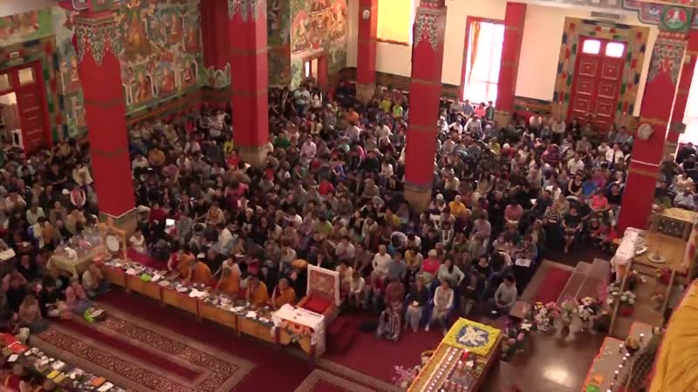

identifier
c5ce3453-6f58-429e-b663-9cac02cb146f

creator
Kalmyk Cultural Heritage Documentation Project

type
Moving Image

coverage
Kalmykia
Russia

description

publisher
University of Cambridge

source
<http://www.kalmykheritage.socanth.cam.ac.uk>

rights
Copyright Kalmyk Cultural Heritage Documentation Project. Licensed under a Creative Commons BY-NC-ND Unported license.

subject
Buddhism
Kalmyks

date
2016-08-24 10:52:04

language

original filename
2301857.mp4

extent
4.3 GiB
11842.400000

format
video/mp4

modified
2017-05-29 12:12:47

remote embed url
http://sms.cam.ac.uk/media/2301619/embed

public
FALSE

