Caroline Humphrey - Buryatia photos - No. 2-31
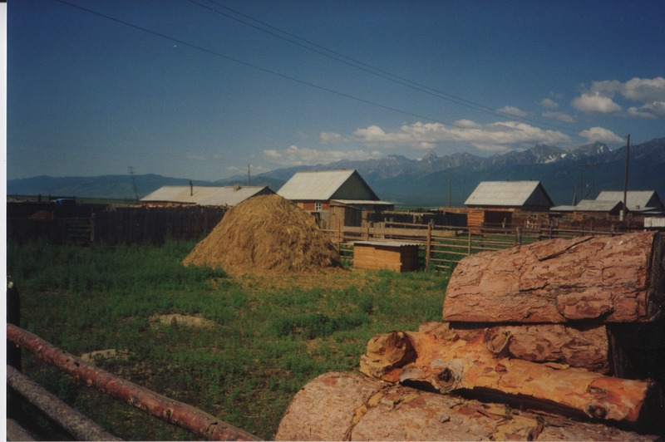

identifier
c7d97616-014f-4285-a711-643f043b54f6

creator
Humphrey, Caroline

type
Image

coverage
Bayangol
Khilgana
Karl Marx Collective
Buryatia
USSR

description
Firewood and hay inside a household yard in the town centre.

publisher

source
Scanned from a print held in the archives of the Mongolia and Inner Asia Studies Unit, University of Cambridge.

rights

subject

date
1993

language

contributor

original filename
Humphrey-Buryatia-photos-2-31.png

relation

extent
3.3MiB
1799x1196 px

format
image/png

