Mongolia, Shaman Ceremony at Mother Rock
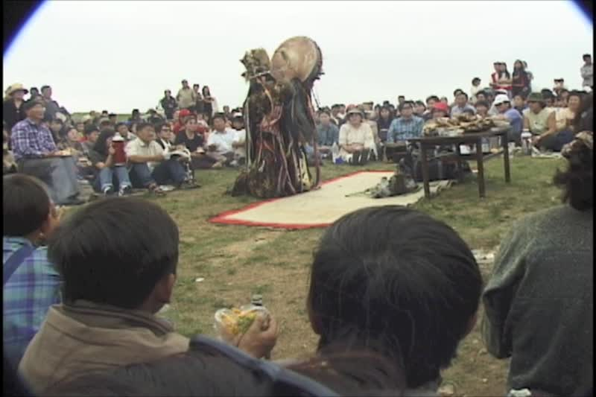

identifier
ccd2b16a-424a-42ef-bd0a-1d2142592786

creator
Penn Museum

type
Moving Image

coverage
Mongolia
Töv aimag

description
Offerings, incense. Crowd, people (many NMMH staff members with family).
[5:04] Pan up to Shaman.
[6:19] Offering.
[8:24] Shaman hits camera for blessing.
[9:40] Shaman hits camera for blessing.
[11:39] Crowd moving from ceremony to Mother Rock.

publisher
University of Pennsylvania Museum of Archaeology and Anthropology Films

source
<https://archive.org/details/UPMAA_films>

rights
All rights are reserved by the University of Pennsylvania Museum of Archaeology and Anthropology (Penn Museum). Any use of the footage in productions is forbidden unless rights have been secured by contacting the Penn Museum Archives at 215-898-8304, or email photos@pennmuseum.org. This film and all of the films in the Penn Museum collection are copyrighted by the Penn Museum, and are not in the public domain.

subject

date
2011-06-23 09:58:58

language
Mongolian

original filename
ShamanRituals.mov

extent
643.1 MiB
718.351667

format
video/quicktime

modified
2011-06-23 01:58:58

remote embed url
https://archive.org/embed/V-450-13

public
FALSE

