Oral history interview No. 080810A with Sugir (b. 1963): transcript
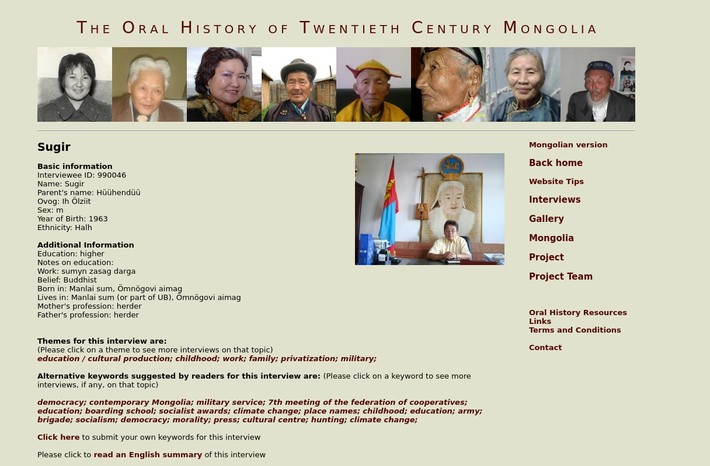

identifier
cf8f875e-a0f1-4f57-8204-0b7e498bcc06

creator
Sugir

type
Text

coverage

description

publisher

source
<http://amantuuh.socanth.cam.ac.uk/search/view_transcript.php?Interview=080810A>

rights
Copyright MIASU. Reproduced with permission. Brief excerpts from interviews and other material may be used in academic or popular work for non-commercial purposes provided proper attribution and credit is given to the Oral History of Twentieth Century Mongolia and the Mongolia and Inner Asia Studies Unit (MIASU). You must not: (a) republish this material (including republication on another website) without the express written permission of MIASU; (b) sell, rent or sub-license material from the website; (c) show any material from the website in public without attribution to The Oral History of Twentieth Century Mongolia; (d) reproduce, duplicate, copy or otherwise exploit material on the website for a commercial purpose without express written permission; (e) use the material in any way that is damaging to the project or any of the persons named in the interviews. See <http://amantuuh.socanth.cam.ac.uk/terms.php> for details.

subject

date
2008

language
Mongolian

format
text/plain

contributor
Oyuntungalag

original filename
080810A-Sugir-transcript.url

relation
9f4932ab-7107-4730-8820-f0300993eafe

extent
79.0 B

