Photographs from Barguzin, No. 10
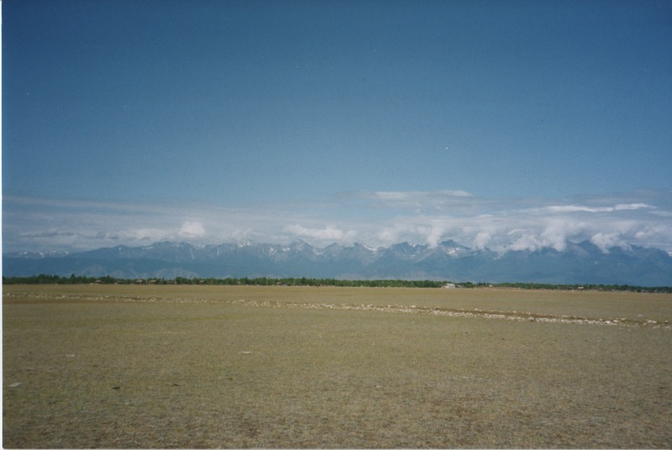

identifier
cfc8446d-7b74-4250-8533-3d1bb7adf2e0

creator
Gomboev, Bair

type
Image

coverage
Barguzin
Burtyatia
Russian Federation

description
Summer pastures, with irrigation that are no longer operational. Bayangol selsoviet, Barguzin Valley.

date
1993-06

language

format
image/png

modified
2017-05-25 10:04:59

original filename
bair-batbuyan-photos-10.png

source
Scanned from a photographic print held in the archives of the Mongolia and Inner Asia Studies Unit, University of Cambridge

extent
3.1 MiB
1777x1191 px

subject
irrigation
rangeland

