Н.Батзаяа, Түүхий сүү, тараг, Оргил хүнс, Гоё тараг үйлдвэрлэхээр ажиллаж байна
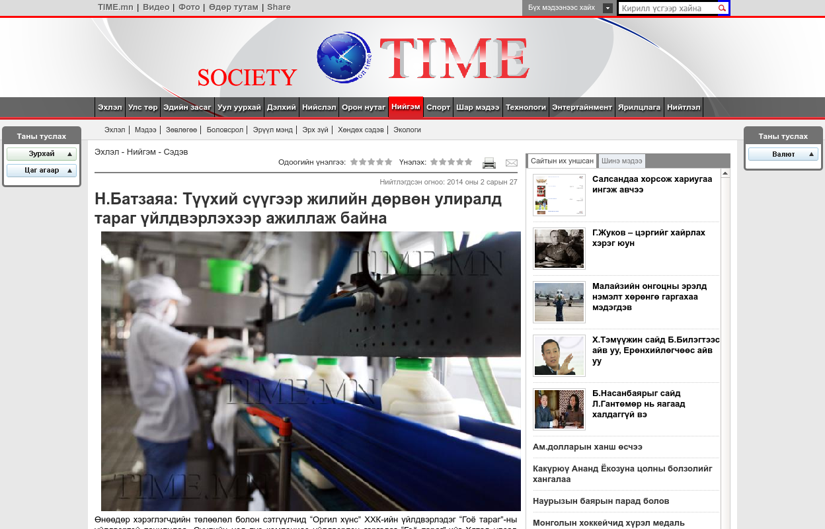

identifier
d13da22d-6529-4e4a-a3cc-a46369a56e08

creator

type
Text

coverage
Mongolia

description

publisher

source
http://society.time.mn/content/42165.shtml

rights

subject
Mongolia
dairy
nationalism
social media

date
24 Mar 2014 14:48:32

language
Mongolian

format
text/plain

modified
2018-01-11 14:12:43

original filename
time.mn.Batzayaa.url

extent
42.0 B

