Visit to Bat-Erdene's home in Yeröö
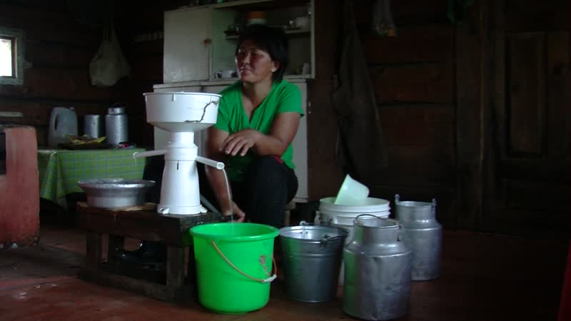

identifier
d2705c36-0568-4bd2-b6af-2ae3b5818124

creator
Thrift, Eric

type
Moving Image

coverage
Mongolia
Selenge aimag
Yeröö sum

description
The recordings in this series depict a visit to Buryat herder Bat-Erdene's home in Tasag, Yeroo sum, Selenge aimag. Bat-Erdene shows off his pigs and chickens, then takes us along as he receives a call from his son to assist with the delivery of a goat kid up on the hill. Back at home, Bat-Erdene's wife separates the cream from the milk obtained from their cattle.

publisher

source

rights

subject
Pastoralism Videos
Farm Livestock
Separating Cream
Goat Birth
Bat-Erdene

date
2012-07-19

language

format
inode/directory

modified
2018-03-02 09:37:44

original filename
PastoralismVideos--2012-07-19--FarmLivestock--SeparatingCream--GoatBirth--Bat-Erdene--Selenge-Yeroo.vclips

table of contents
time | clip | description
0:00:00 | 300G0039 01 | Bat-Erdene's pigs.
0:01:23 | 300G0040 01 | The piglets.
0:03:04 | 300G0041 01 | Newborn calves.
0:07:14 | 300G0042 01 | Bat-Erdene feeds his chickens. He takes Ananda and Naranjargal to see the piglets, and feeds the sow, then everyone walks back towards the house.
0:18:35 | 300G0043 01 | Bat-Erdene is called by his son to assist the delivery of a goat kid up on the hill. He delivers the kid, then waits while the mother licks off the placenta. Naranjargal and Ananda stand watching. Bat-Erdene places the newborn kid in a sack and carries it with him back to the car.
0:28:22 | 300G0044 01 | Newborn goat kid inside the entranceway of Bat-Erdene's house.
0:29:30 | 300G0045 01 | Bat-Erdene's wife separates cream.
0:43:24 | 300G0045 02 | Bat-Erdene's wife separates cream.
0:49:45 | 300G0052 01 | Bat-Erdene's wife separates cream. The children have been playing outdoors; they come into the entranceway to look at the newborn goat kid and chicks.
1:03:39 | 300G0052 02 | Bat-Erdene's wife separates cream. Narangarav tries operating the separator.
1:13:23 | 300G0053 01 | Narangarav continues operating the separator, then hands it back to Bat-Erdene's wife. Bat-Erdene comes in and joins in the talk.
1:27:17 | 300G0053 02 | Bat-Erdene's wife finishes separating the cream, and dismantles the separator.

