Caroline Humphrey - Buryatia photos - No. 04
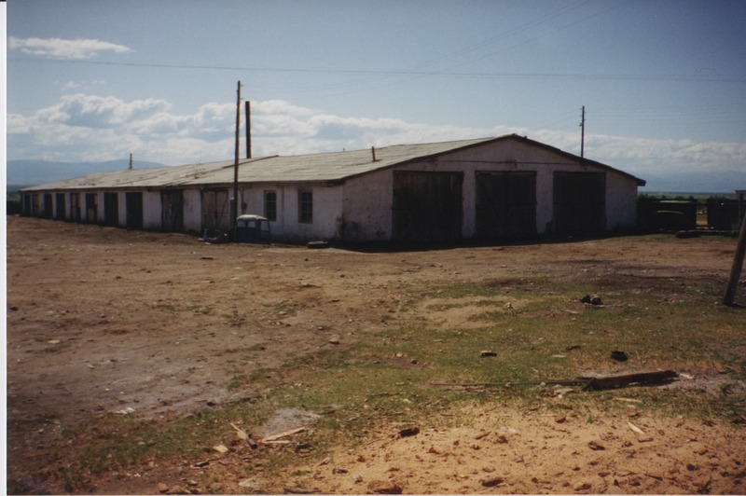

identifier
d310eea5-3498-45ed-91ac-c0e8dc8f4c5b

creator
Humphrey, Caroline

type
Image

coverage
Ulung Collective
Buryatia
USSR

description

publisher

source
Scanned from a print held in the archives of the Mongolia and Inner Asia Studies Unit, University of Cambridge.

rights

subject

date
1993-07-25

language

extent
3.3MiB
1799x1196 px

contributor

original filename
Humphrey-Buryatia-photos-04.png

relation

format
image/png

