Photograph from Inner Mongolia, No. 13
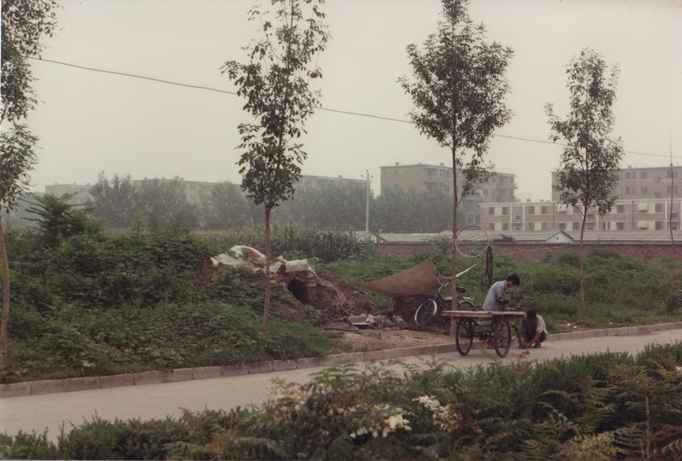

identifier
d4535aaa-e214-4341-addf-03e12ddcf3c9

creator
Sneath, David

type
Image

coverage
Inner Mongolia
PRC

description
Itinerant/migrant workers near Beijing, living in an excavated area by the side of the road.

publisher

source
Scanned from a photographic print held in the archives of the Mongolia and Inner Asia Studies Unit, University of Cambridge.

rights

subject
migrant labour

date
ca. 1988

language

original filename
sneath-inner-mongolia-1980s.png_13.png

relation

extent
3.3 MiB
1747x1182 px

contributor

format
image/png

modified
2017-05-25 11:05:50

