Caroline Humphrey - Buryatia photos - No. 17
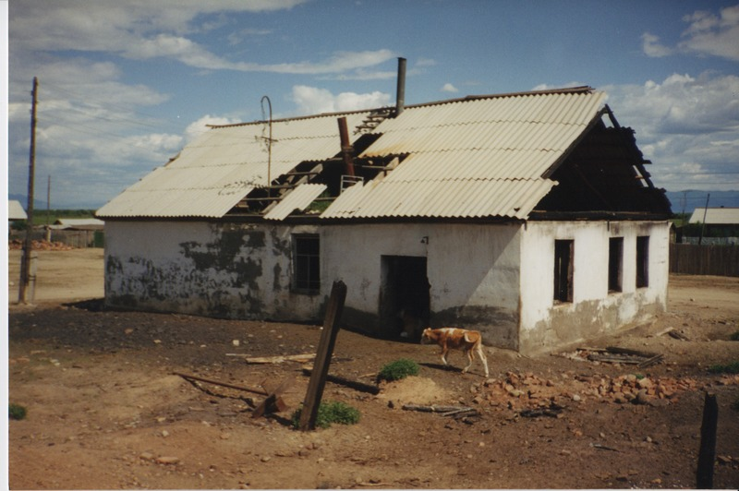

identifier
d53dcc4c-181d-4a3a-bc81-c9c41dadfc0d

creator
Humphrey, Caroline

type
Image

coverage
Ulung Collective
Buryatia
USSR

description
Power station.

publisher

source
Scanned from a print held in the archives of the Mongolia and Inner Asia Studies Unit, University of Cambridge.

rights

subject

date
1993-07-25

language

contributor

original filename
Humphrey-Buryatia-photos-17.png

relation

extent
3.3MiB
1799x1196 px

format
image/png

