Caroline Humphrey - Buryatia photos - No. 4-03
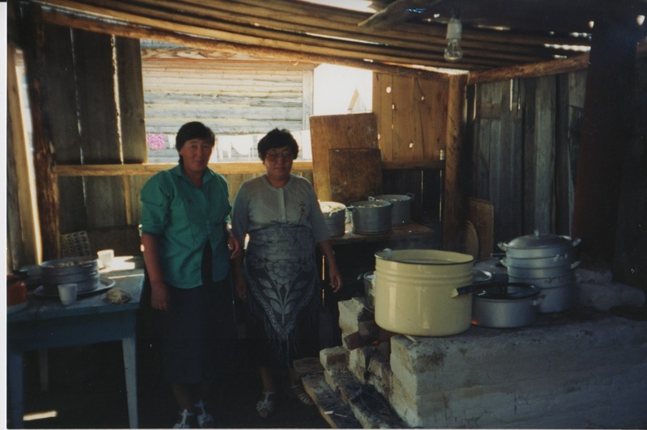

identifier
d5d29542-50e7-4d34-9430-f8173a1fae4f

creator
Humphrey, Caroline

type
Image

coverage
Uro
Bayangol
Buryatia
USSR

description
Wedding preparations

publisher

source
Scanned from a print held in the archives of the Mongolia and Inner Asia Studies Unit, University of Cambridge.

rights

subject

date
1993

language

contributor

original filename
Humphrey-Buryatia-photos-4-03.png

relation

extent
3.2MiB
1799x1196 px

format
image/png

