Photograph from Govisumber, No. 13
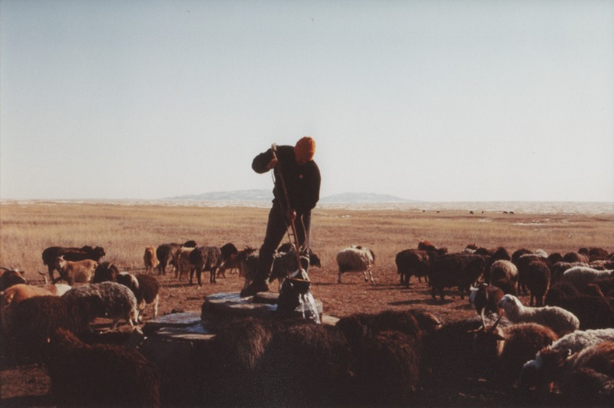

identifier
d65321a4-357e-4611-b36b-52c3272a8b35

creator
Sneath, David

type
Image

coverage
Govisumber aimag
Mongolia

description

publisher

source
scanned from a photographic print held in the archives of the Mongolia and Inner Asia Studies Unit, University of Cambridge

rights

subject
water use
watering livestock
wells

date
1995

language

format
image/png

contributor

original filename
sneath-govisumber_13.png

relation

extent
1776x1182 px
3.1MiB

