АПУ, Сүү, Витафит компаниудын хортой сүү ард түмнийг | Chuhal.mn
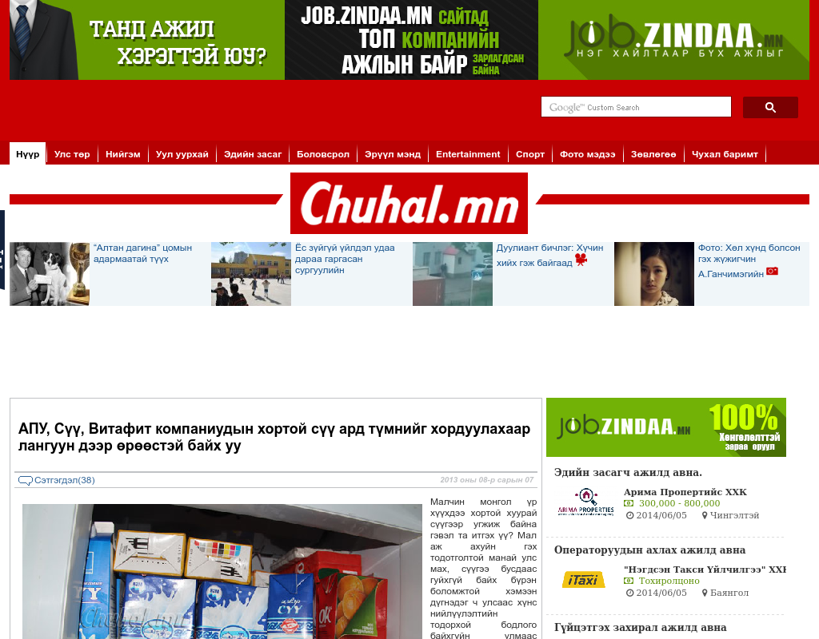

identifier
daf46915-22de-4b30-bb5d-ce8c74f5721c

creator

type
Text

coverage
Mongolia

description

publisher

source
http://chuhal.mn/r/27677

rights

subject
Mongolia
dairy
nationalism
social media

date
9 Jun 2014 20:56:24

language
Mongolian

format
text/plain

modified
2018-01-11 14:12:43

original filename
chuhal.mn.APU_Suu_Vitafit.url

extent
24.0 B

