Camel transportation
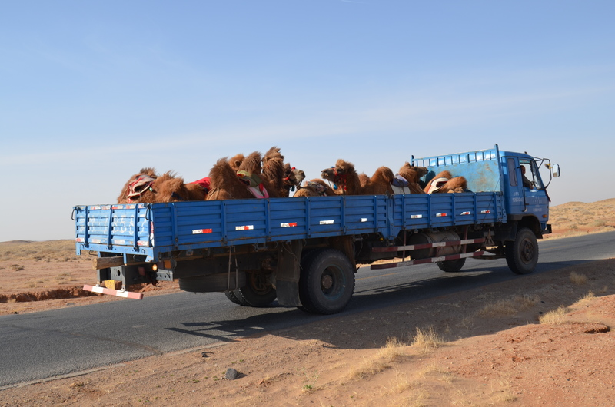

identifier
dd194cf1-2bd8-494e-baee-d670f0f339e9

creator
White, Thomas

type
Image

coverage
Alashan
Inner Mongolia
PRC

description
Camels being transported to a race in the back of a truck.

publisher

source
Image submitted by the author.

rights
Copyright Thomas White. All rights reserved. Please contact the author for information on re-use.

subject
camels

date
2013-04-29 02:51:04

language

format
image/jpeg

contributor

original filename
DSC_0131.JPG

relation

extent
3.9MiB
4928x3264 px

