Caroline Humphrey - Buryatia photos - No. 2-29
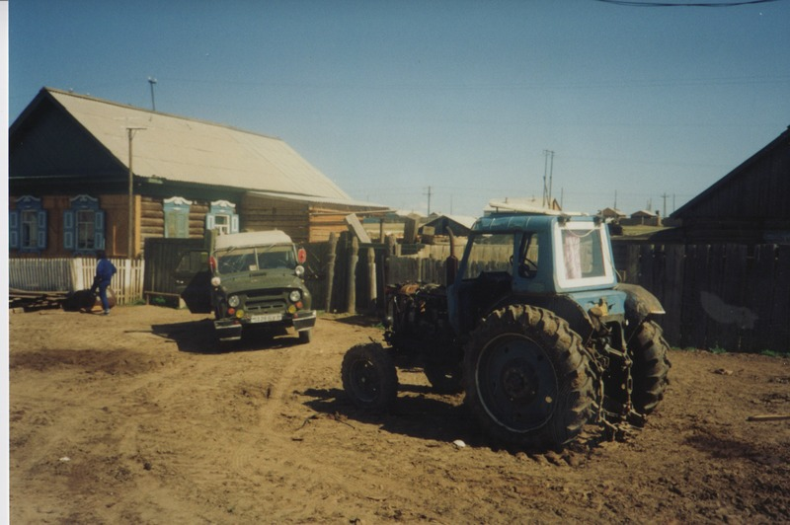

identifier
de3525e6-1ab3-40ee-a63f-868f8fbb5fd3

creator
Humphrey, Caroline

type
Image

coverage
Bayangol
Khilgana
Karl Marx Collective
Buryatia
USSR

description
Tractor and jeep.

publisher

source
Scanned from a print held in the archives of the Mongolia and Inner Asia Studies Unit, University of Cambridge.

rights

subject

date
1993

language

contributor

original filename
Humphrey-Buryatia-photos-2-29.png

relation

extent
3.2MiB
1799x1196 px

format
image/png

