Oral history interview No. 090745A with Garamhand (b. 1934): translation
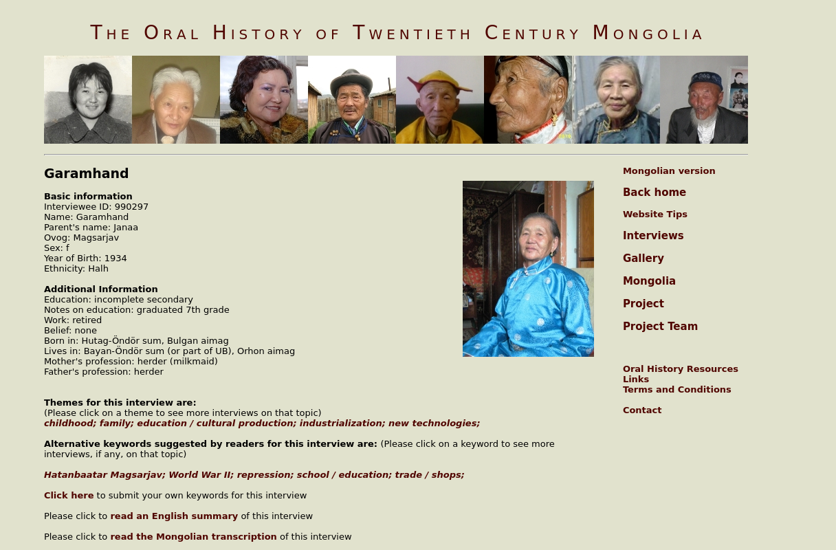

identifier
de47110a-8d55-4bf2-82bb-585964ff35ac

creator
Garamhand

type
Text

coverage
Mongolia
Orkhon aimag

description
J.Garamkhand was born in 1934 in Hutag-Öndör sum, Bulgan aimag, in a place called Bürged. She spent her childhood with her parents. In 1948, instead of her mother, she attended the literacy group training for six days and learned the 35 letters. In 1962 she completed a seventh grade education at night school. She is the relative of Hatanbaatar Magsarjav and she talked quite a bit about what she had heard and what she knew about that person, the things he used to consume and about his family and his children. She can’t sing but likes songs and music very much and fond of watching movies and concerts, and public dance circles. She worked at the carpet factory, the sixth arteli, in trade and the self-service store. She talked in detail how the people of that time worked, the peculiarities of the work places, how industry was developed in Mongolia, what was the salary of the people, the purchasing power of the people, and the provisioning of goods.

publisher
Oral History of Twentieth Century Mongolia

source
<http://amantuuh.socanth.cam.ac.uk/search/view_trans.php?Interview=090745A>

rights
Copyright MIASU. Reproduced with permission. Brief excerpts from interviews and other material may be used in academic or popular work for non-commercial purposes provided proper attribution and credit is given to the Oral History of Twentieth Century Mongolia and the Mongolia and Inner Asia Studies Unit (MIASU). You must not: (a) republish this material (including republication on another website) without the express written permission of MIASU; (b) sell, rent or sub-license material from the website; (c) show any material from the website in public without attribution to The Oral History of Twentieth Century Mongolia; (d) reproduce, duplicate, copy or otherwise exploit material on the website for a commercial purpose without express written permission; (e) use the material in any way that is damaging to the project or any of the persons named in the interviews. See <http://amantuuh.socanth.cam.ac.uk/terms.php> for details.

subject
Khatanbaatar Magsarjav
World War II
education
oral history
repression
trade

date
2009

language
English

format
text/plain

contributor
Khishigsüren

original filename
090745A-Garamhand-translation.url

relation
4c76be39-a7ae-414f-9455-1856da3c2835

extent
74.0 B

