9402
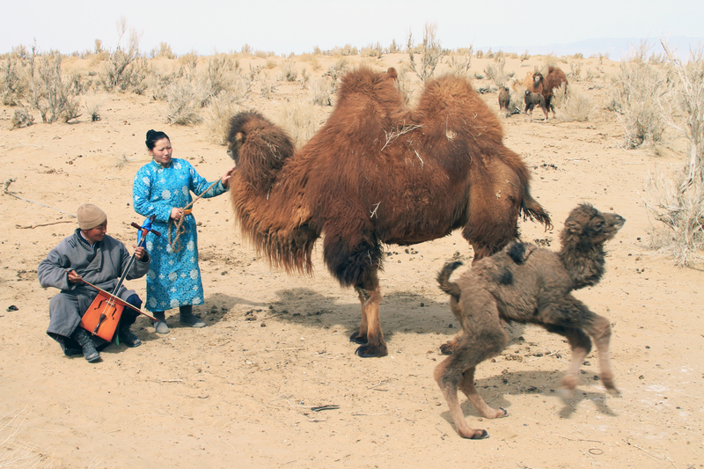

identifier
de8c4cb1-c7b1-4fb4-9405-09e7dd211581

creator
Boldbaatar, Yu.

type
Image

coverage
Mongolia

description
The coaxing ritual for baby camels-1

publisher

source
https://ich.unesco.org/img/photo/src/09402.jpg

rights

subject

date
2011

language

original filename
09402.jpg

extent
10.7 MiB
5184x3456 px

format
image/jpeg

modified
2016-02-24 14:45:58

