Map of Inner Asia
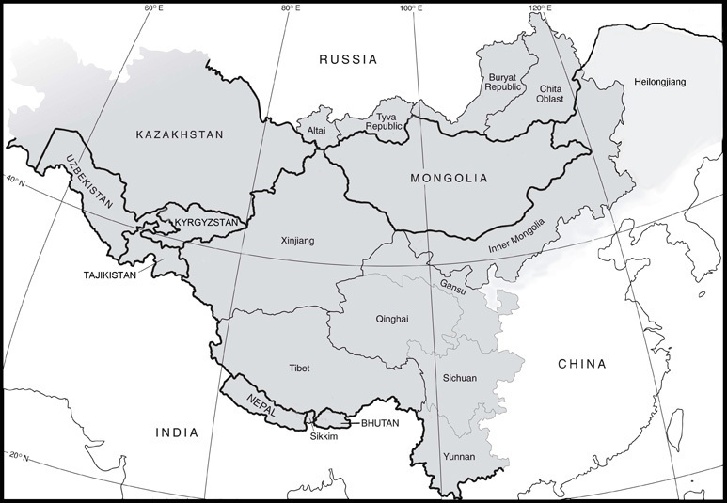

identifier
e090c687-5959-4654-bc61-654813b5e0b9

creator
MIASU

type
Image

coverage
Inner Asia

description
Map showing the region taken as “Inner Asia”, prepared by the Mongolia and Inner Asia Studies Unit, Department of Social Anthropology, University of Cambridge.

publisher

source

rights

subject
Inner Asia
maps

date
2017

language
English

format
image/jpeg

modified
2017-10-07 15:40:39

original filename
miasu-map.jpg

extent
93.8 KiB
773x535 px

contributor
MIASU

