Expeditions of Sven Hedin
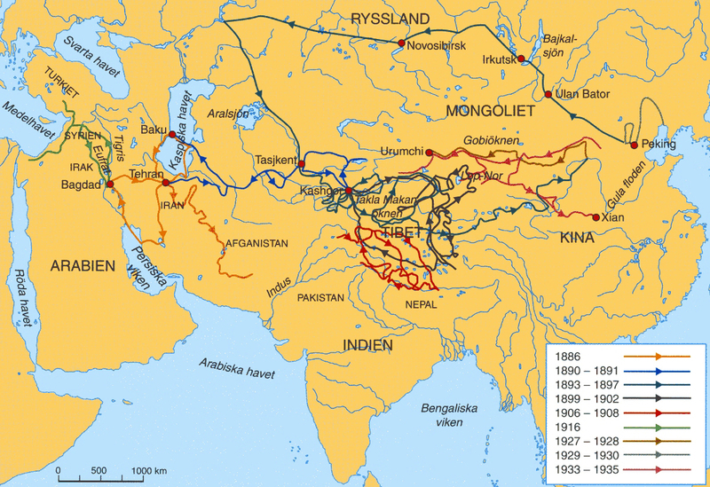

identifier
e6ae7586-0b1a-459f-99e8-e19e4b21826d

creator
Unknown

type
Image

coverage
Inner Asia

description
Map depicting the routes of Sven Hedin’s exploring expeditions, 1886-1935.

publisher

source
<https://commons.wikimedia.org/wiki/File:Exploring_expeditions_of_Sven_Hedin_1886-1935.jpg>
Digitized by Sven Hedin Foundation.
Med världen i kappsäcken. Samlingarnas väg till Etnografiska museet. *Etnografiska museet*, Stockholm 2002, page 236.

rights
Permission cc-by-2.5 of the date 2006.08.23 by the keeper of the Sven Hedin Foundation Håkan Wahlquist, Box 27 140, SE-102 52 Stockholm, Sweden, Phone: +46-8-519 550 18, fax: +46-8-519 550 70, e-mail: hakan.wahlquist@etnografiska.se

subject
expeditions
maps

date
2002

language
Swedish

format
image/jpeg

modified
2017-10-09 11:58:31

original filename
Exploring_expeditions_of_Sven_Hedin_1886-1935.jpg

extent
1.0 MiB
1200x823 px

