Travels in Tartary, Thibet and China during the years 1844-5-6, Vol. 2
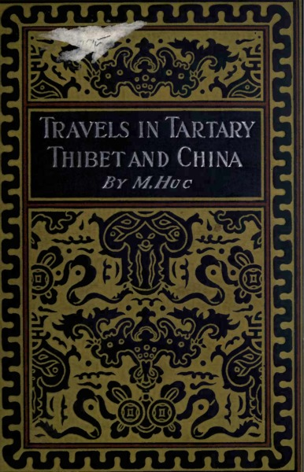

identifier
ed0513dd-f185-4434-a7ff-798fc66ad43d

creator
Huc, Evariste Régis

type
Text

coverage
Inner Mongolia
Mongolia
PRC

description
Évariste Régis Huc, C.M., (1813–1860) was a French missionary Catholic priest and traveller.
From the preface: The Pope having, about the year 1844, been pleased to establish an Apostolic Vicariat of Mongolia, it was considered expedient, with a view to further operations, to ascertain the nature and extent of the diocese thus created, and MM. Gabet and Huc, two Lazarists attached to the petty mission of Si-Wang, were accordingly deputed to collect the necessary information. They made their way through difficulties which nothing but religious enthusiasm in combination with French elasticity could have overcome, to Lha-Ssa, the capital of Thibet, and in this seat of Lamanism were becoming comfortably settled, with lively hopes and expectations of converting the Talé-Lama into a branch-Pope, when the Chinese Minister, the noted Ke-Shen, interposed on political grounds, and had them deported to China. M. Gabet was directed by his superiors to proceed to France, and lay a complaint before his Government, of the arbitrary treatment which he and his fellow Missionary had experienced. In the steamer which conveyed him from Hong Kong to Ceylon, he found Mr. Alexander Johnstone, secretary to Her Majesty’s Plenipotentiary in China; and this gentleman perceived so much, not merely of entertainment, but of important information in the conversations he had with M. Gabet, that he committed to paper the leading features of the Reverend Missionary’s statements, and on his return to his official post, gave his manuscripts to Sir John Davis, who, in his turn, considered their contents so interesting, that he embodied a copy of them in a dispatch to Lord Palmerston. Subsequently the two volumes, here translated, were prepared by M. Huc, and published in Paris. Thus it is, that to Papal aggression in the East, the Western World is indebted for a work exhibiting, for the first time, a complete representation of countries previously almost unknown to Europeans, and indeed considered practically inaccessible; and of a religion which, followed by no fewer than 170,000,000 persons, presents the most singular analogies in its leading features with the Catholicism of Rome.

publisher
Open Court Publishing Company

source
<https://archive.org/details/travelsintartary02huceiala>
Scanned by University of California Libraries

rights
Public domain

subject
expeditions

date
1852

language
English

original filename
travelsintartary02huceiala.pdf

extent
28.8 MiB

contributor
Hazlitt, W

remote embed url
https://archive.org/stream/travelsintartary02huceiala?ui=embed

format
application/pdf

modified
2017-10-09 12:16:45

