Caroline Humphrey - Buryatia photos - No. 4-04
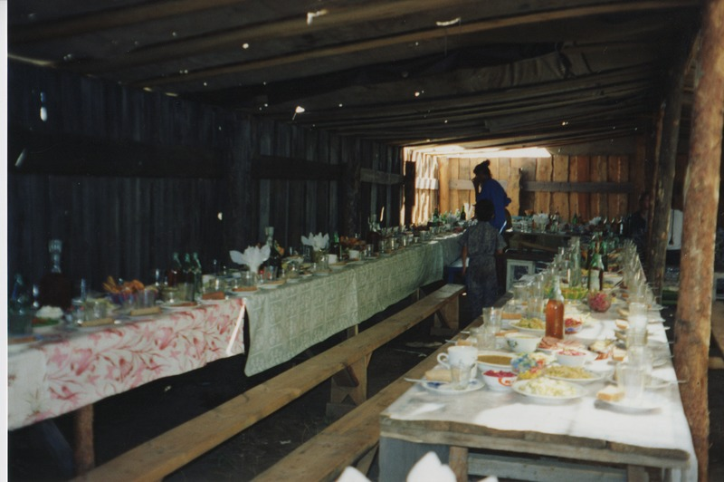

identifier
ed99dacb-a358-445a-9809-abddd39617f5

creator
Humphrey, Caroline

type
Image

coverage
Uro
Bayangol
Buryatia
USSR

description
Wedding preparations -- the tables for guests.

publisher

source
Scanned from a print held in the archives of the Mongolia and Inner Asia Studies Unit, University of Cambridge.

rights

subject

date
1993

language

contributor

original filename
Humphrey-Buryatia-photos-4-04.png

relation

extent
3.3MiB
1799x1196 px

format
image/png

